# Abdulrahman

# 21F-9609

# BCS-6E

Web Programming

Task#1

<!DOCTYPE html>

<html lang="en">

<head>

    <meta charset="UTF-8">

    <meta name="viewport" content="width=device-width, initial-scale=1.0">

    <title>Lab Task#1</title>

</head>

<body>

    <h1>Name: Abdulrahman</h1>

    <h2>Roll No: 21F-9609</h2>

    <h3>About:</h3>

    <p>Hello! Im Abdulrahman from Lahore. Im 20 years old. Im a Computer Science student at Fast NUCES.</p>

</body>

</html>

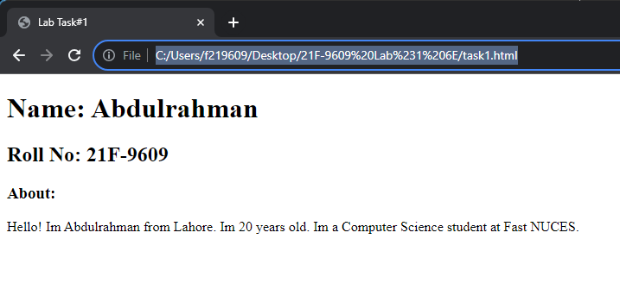

Task#2

<!DOCTYPE html>

<html lang="en">

<head>

    <meta charset="UTF-8">

    <meta name="viewport" content="width=device-width, initial-scale=1.0">

    <title>Lab Task#2</title>

</head>

<body>

    <b>This text is bold</b>

    <strong><br>This text is strong</strong>

    <big><br>This text is big</big>

    <i><br>This text is italic</i>

    <em><br>This text is emphasized</em>

    <p><br>This is computer output</p>

    <sub><br>This is subscript</sub>

    <sup><br>This is superscript</sup>

</body>

</html>

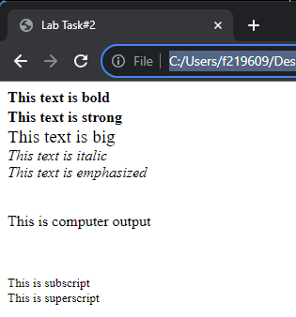

Task#3 and Task#4

<!DOCTYPE html>

<html lang="en">

<head>

    <meta charset="UTF-8">

    <meta name="viewport" content="width=device-width, initial-scale=1.0">

    <title>Lab Task#3</title>

</head>

<body>

  <a href="https://www.nu.edu.pk/">  <img src="Fast_logo.png" alt="Fast NUCES" width="500" height="500"> </a>

</body>

</html>





Task#5

<!DOCTYPE html>

<html lang="en">

<head>

    <meta charset="UTF-8">

    <meta name="viewport" content="width=device-width, initial-scale=1.0">

    <title>Lab Task#5</title>

</head>

<body>

    <h1>HTML Lists</h1>

    <h2>Unordered List</h2>

    <p>We have books on a variety of languages. <br></p>

    <ul>

        <li>Oracle</li>

        <li>Java</li>

        <li>HTML</li>

        <li>CSS</li>

    </ul>

    <h2>Ordered List</h2>

    <p>Follow these steps to install Java: <br></p>

    <ol>

        <li>Download the software.</li>

        <li>Extract to a folder</li>

        <li>Double click the executable to run.</li>

    </ol>

</body>

</html>

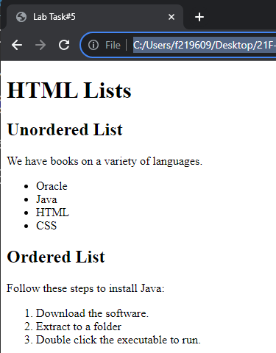

Task#6

<!DOCTYPE html>

<html lang="en">

<head>

    <meta charset="UTF-8">

    <meta name="viewport" content="width=device-width, initial-scale=1.0">

    <title>Lab Task#6</title>

</head>

<body>

    <table border=".5" width = "300" height = "100">

      <thead>

        <tr>

            <th rowspan="3">April</th>

            <td></td>

            <td></td>

        </tr>

        <tr>

            <td></td>

            <td></td>

        </tr>

        <tr>

            <td></td>

            <td></td>

        </tr>

        <tr>

            <td></td>

            <td></td>

            <td></td>

        </tr>

        <tr>

            <td></td>

            <td></td>

            <td></td>

        </tr>

      </thead>

    </table>

</body>

</html>

